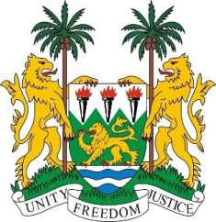
SIERRA LEONE

27th Session of the UPR

INDIA

4 May 2017

Mr President,

Sierra Leone welcomes the high-level delegation from India to this review cycle and thanks them for their presentation.

India is widely acknowledged as being a very diverse, multi-ethnic, multi-linguistic and pluralistic society. The cohesive functioning of its many interlinked organs, through its whole-of-Government Approach to the implementation of the SDGs, including programmes such as the Digital India Program of 2015 and the Aadhaar card scheme must be applauded.

Sierra Leone also notes that India has consistently contributed to the OHCHR since 2012 and has expressed its commitment to continue working with the U.N. and international partners to combat human rights violations.

Sierra Leone is concerned about incidents of sexual violence against women and urges India to intensify its efforts to address this.

Recommendations:

- Expedite efforts to ratify the ICPPED and the CAT.
- Step up efforts to combat and eliminate child, early and forced marriages.
- Review the Criminal Procedure Code as regards the use of force by law enforcement officials, in particular, section 46.

Finally, Sierra Leone wishes India every success in this third review cycle.

Thank you, Mr President.

